

Assignment-04
CV Maker Project

Submitted by:
Ahmad / SP25-BCS-007
Muhammad Usama / SP25-BCS-151
Submitted to:
Sir Muhammad Shahid Bhatti
Course Name:
Object Oriented Programming
December 10,2025

COMSATS UNIVERSITY ISLAMABAD,
LAHORE

Content:
Introduction
Objectives
project description
Final display
CV’s sample
UML diagram
CV Maker Project
Introduction:
This Java OOP GUI project is a CV Maker application designed to help users create professional resumes easily. It allows users to sign up, log in, and manage their CVs through a graphical interface. Users can choose from three templates—Simple, Modern, and Professional—customize colors, enter personal and professional information, and generate a CV. The application also provides options to preview, edit, print, and export the CV to PDF, ensuring a complete and user-friendly resume-building experience.

Objectives:
- User Registration and Login:
  - Provide a secure account sign-up and login system.
  - Save user credentials and allow authenticated access.
- Dashboard for CV Management:
  - Display recently created CVs.
  - Allow users to open, edit, or delete existing CVs.
  - Provide a clear option to create a new CV.
- Template Selection:
  - Offer three template types: Simple, Modern, Professional.
  - Display color variations for each template.
  - Show real-time preview before selection.
- Data Collection and CV Generation:
  - Take all necessary information from the user (personal details, education, skills, experience, etc.).
  - Automatically place the data into the selected CV design.
- Output and Actions:
  - Allow editing after generation.
  - Enable printing and export to PDF.
  - Provide a live preview at any stage.
- User Experience and Interface:
  - Use OOP principles to keep the code structured and reusable.
  - Provide a neat and intuitive GUI.
  - Include a logout button for security.

Project Description:

This project is a Java OOP-based CV Maker application with a graphical user interface. It allows users to create, manage, and export professional CVs through a simple workflow. New users start by creating an account through a sign-up page. After successful login, the main dashboard displays all recently created CVs and provides an option to create a new one. When creating a CV, the user can select from three templates — Simple, Modern, and Professional — each with different color variations and layout designs. A live preview area at the bottom of the template page shows how the CV will look. After selecting a template, the user enters personal and professional details, which are automatically organized into the CV format. Once a CV is generated, tools appear on the top-right corner for editing, printing, exporting to PDF, and previewing. A logout button is also available for secure session handling. The aim of this project is to provide an easy and efficient way for users to build high-quality CVs without design experience.

Final Display

Login /signup
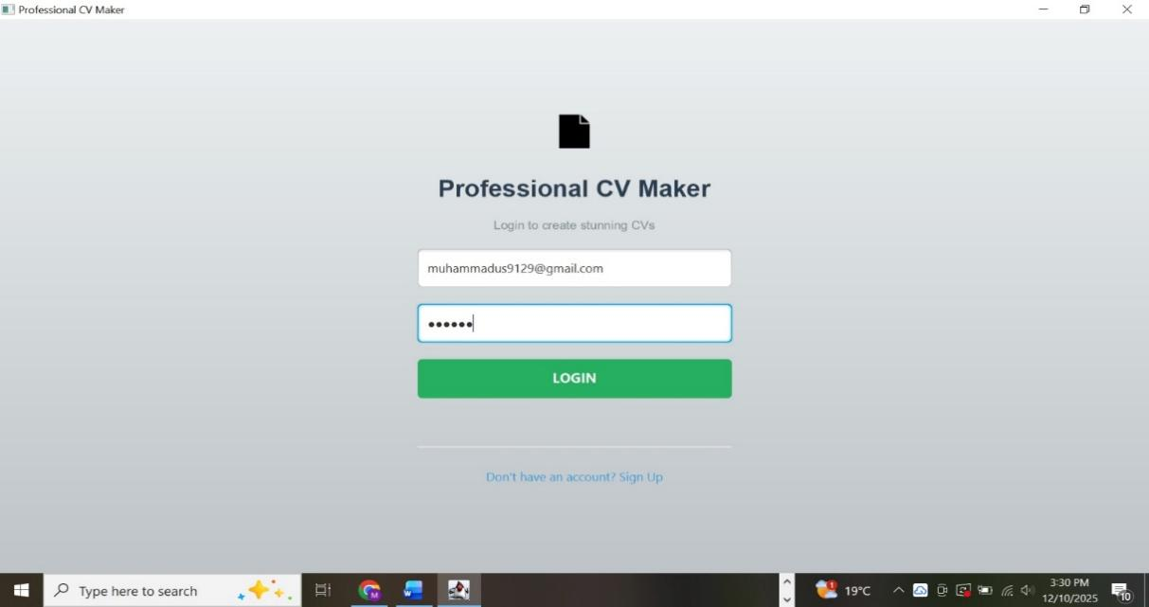

Sign up and opt authetication

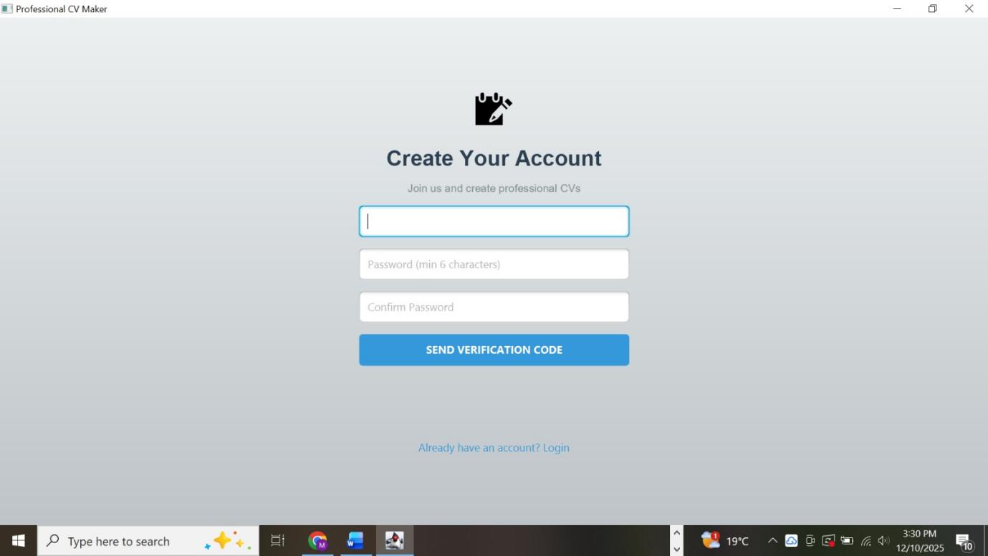

Add date

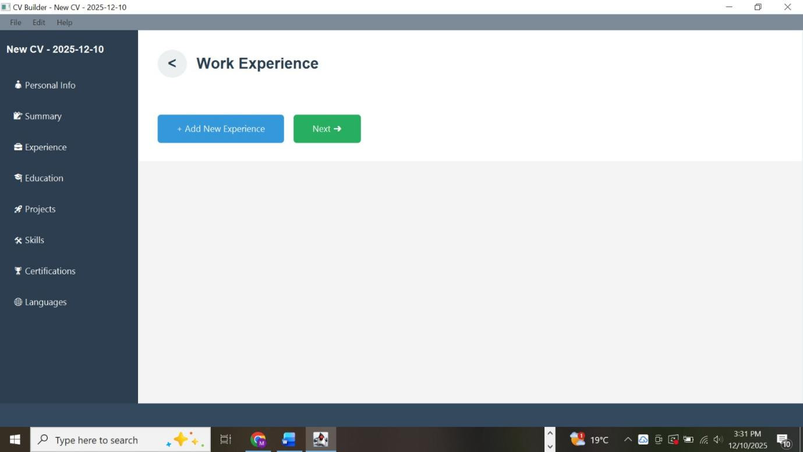

Auto save CV on dashboard with date and time
with log out your account
and welcome note

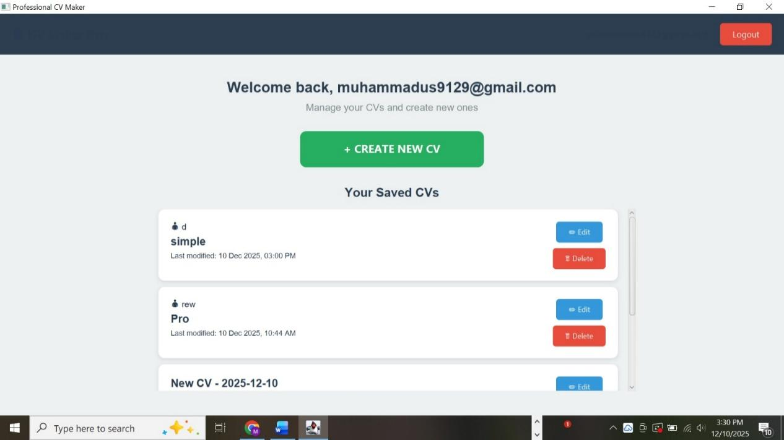

Select different templates with desired color and live preview

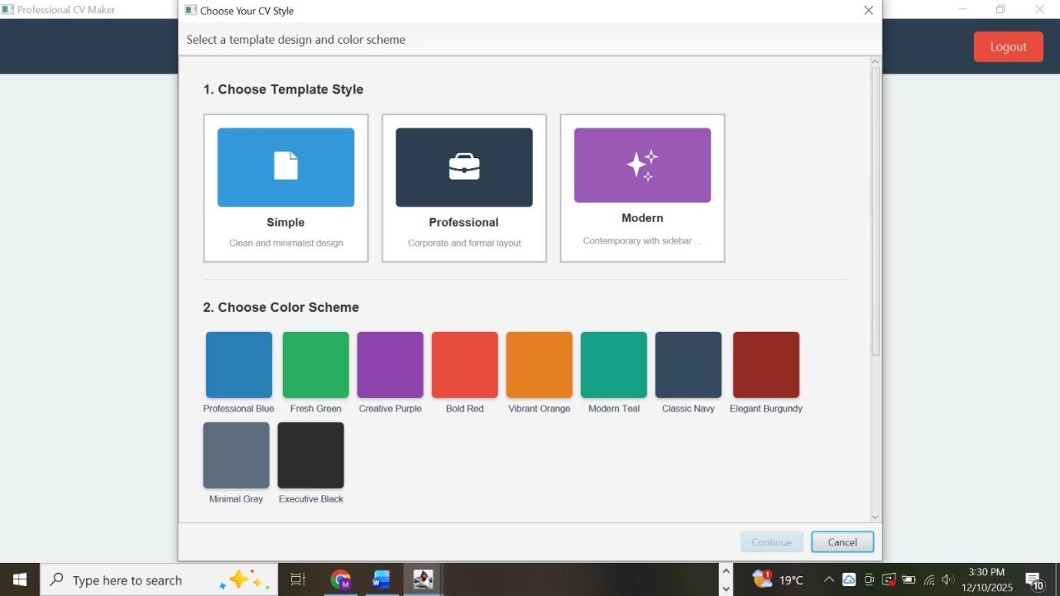

Add Skills
Save skills and jump to certification phase

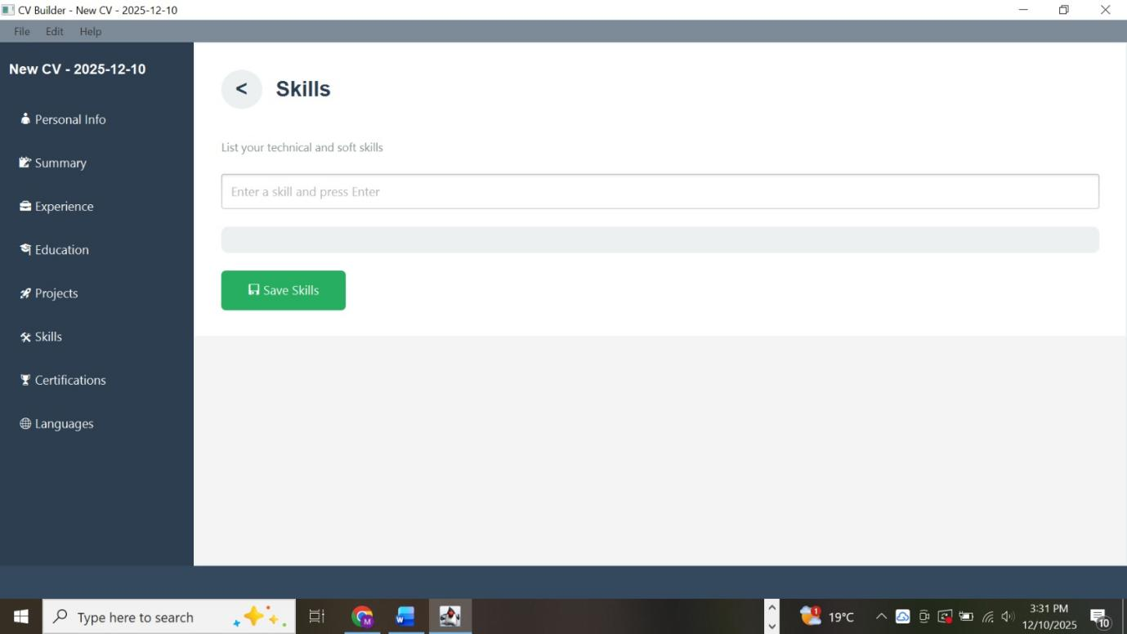

Add Projects
with proper validation

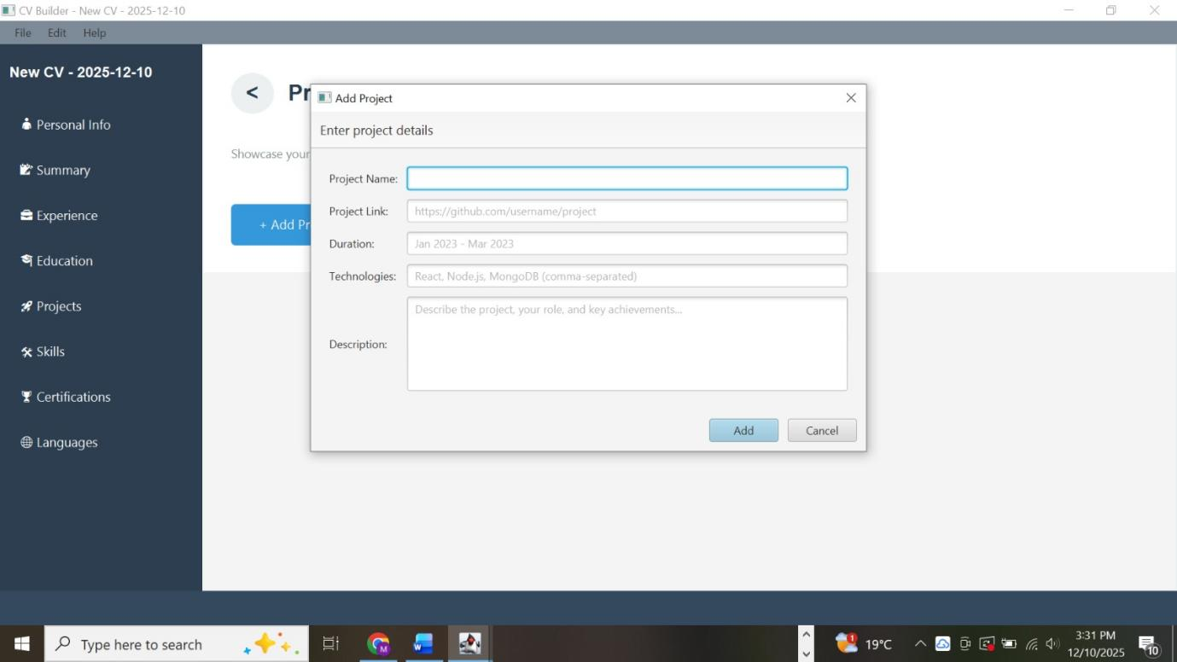

Certification data Validation

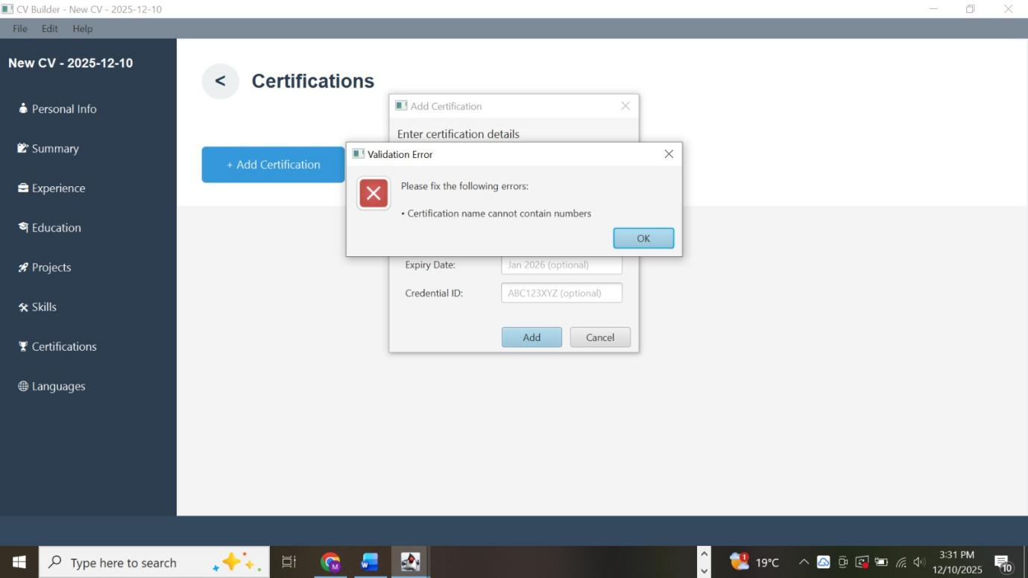

Back to dashboard ,print and , export pdf and save CV on dashboard

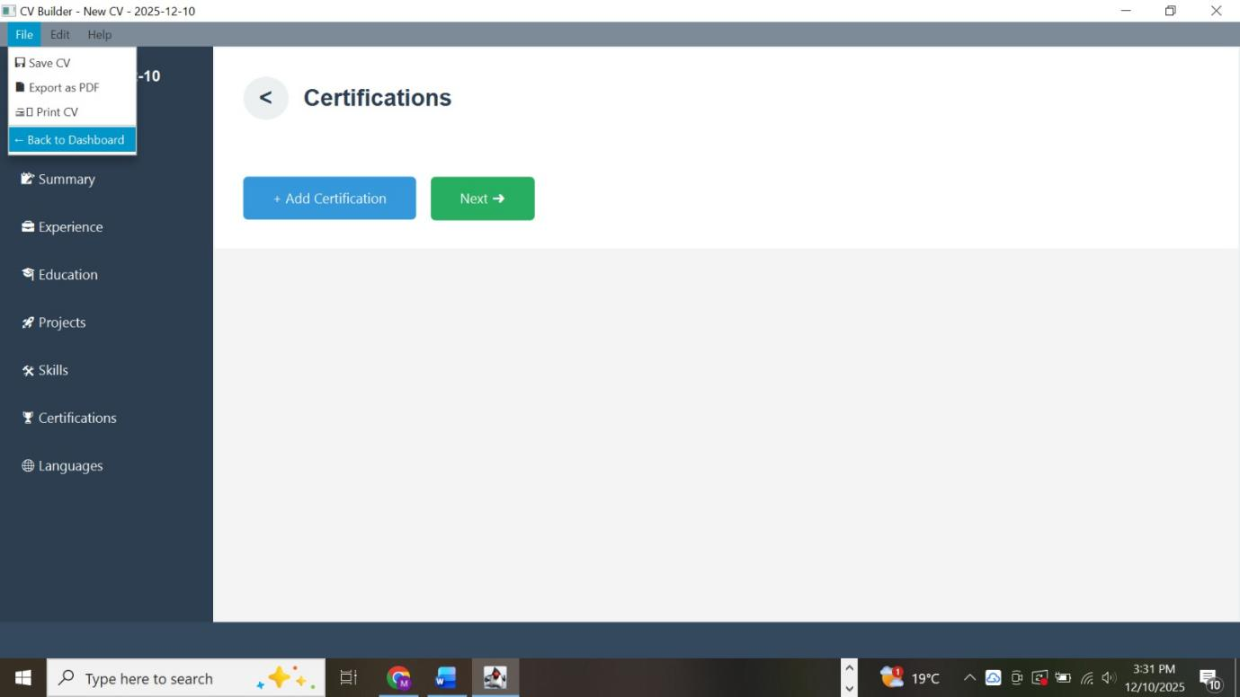

Preview CV after all date Entry
you can print ,export ,edit or go back

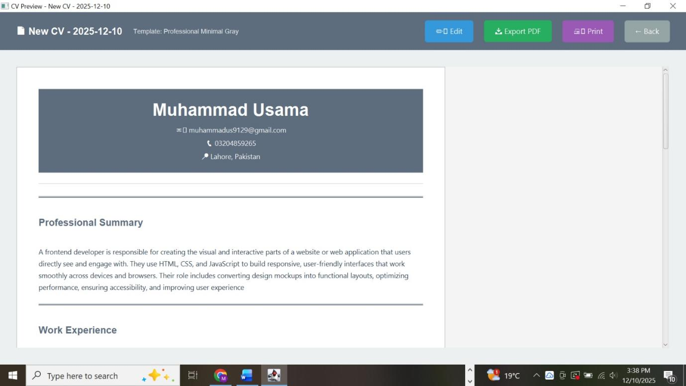

Print CV option with further options of printer name, page selection etc..

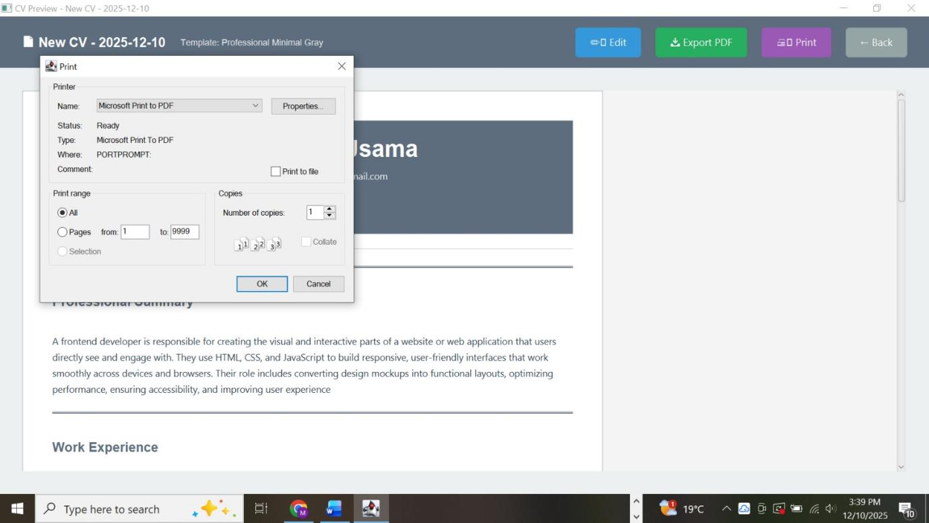

Export pdf , we can select desired path and can open on word , wps

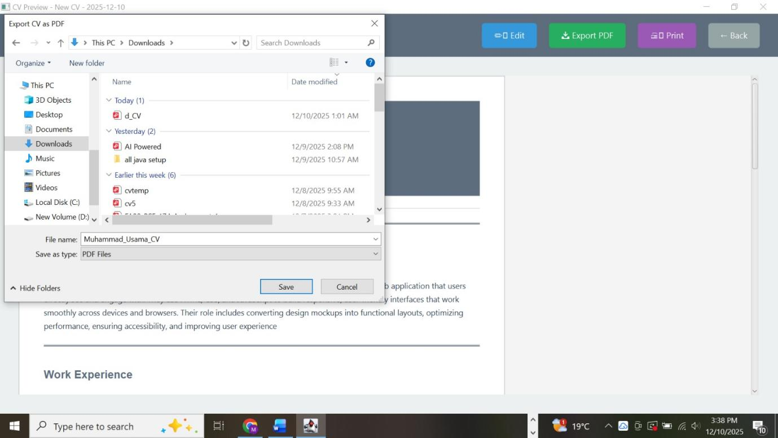

Work experience can be more than one

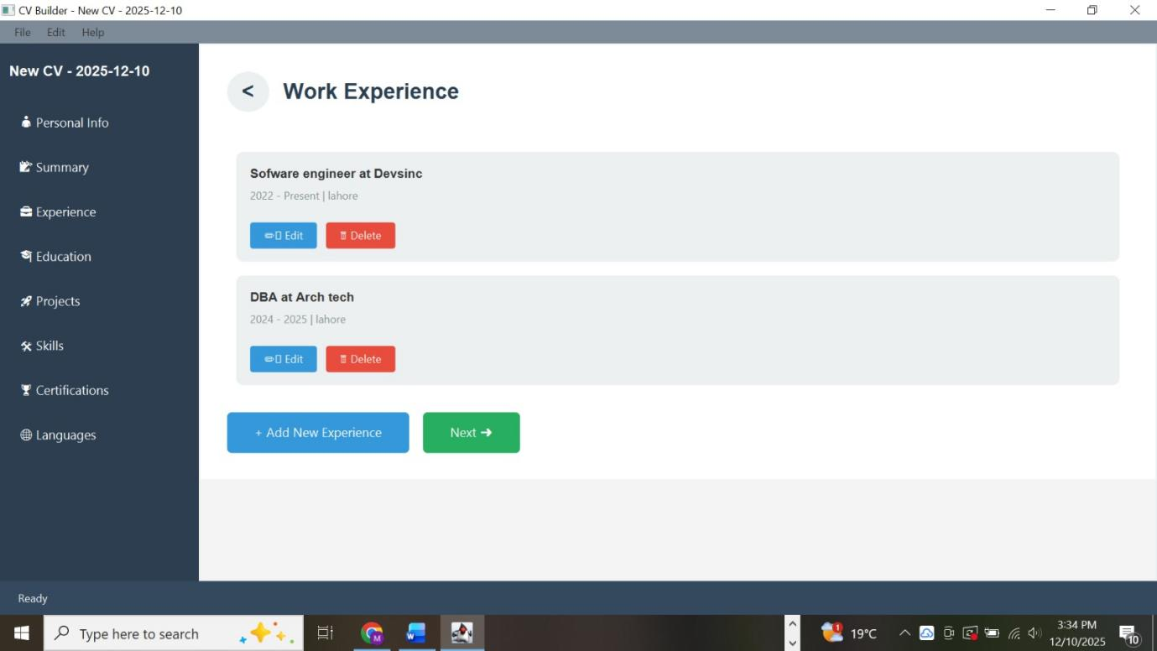

Sample CV’s
Simple template

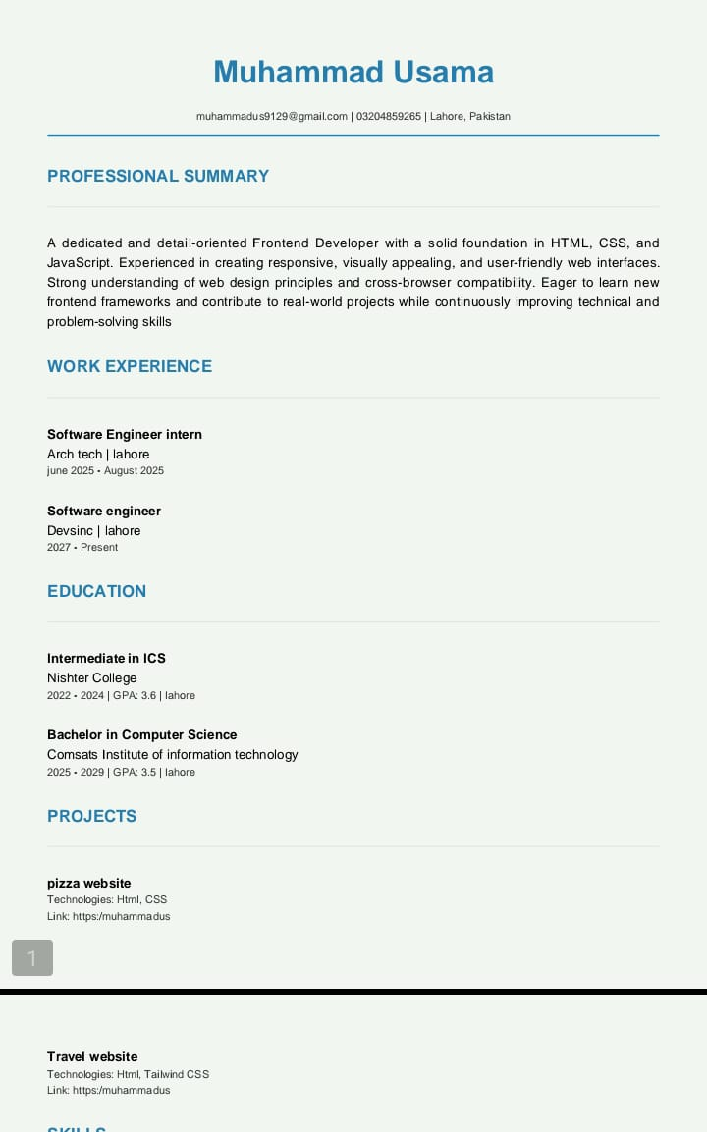

Professional template

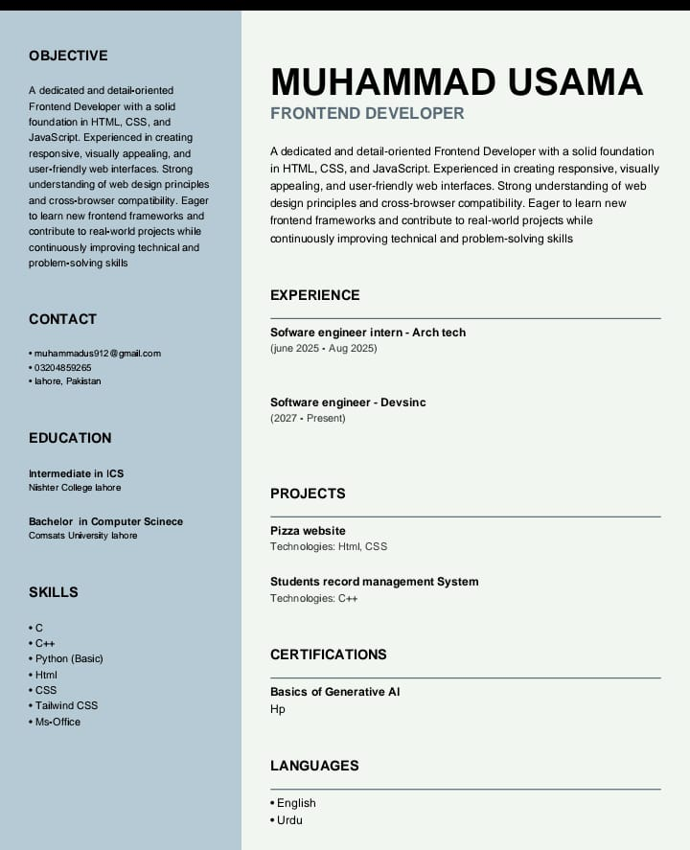

Modern template

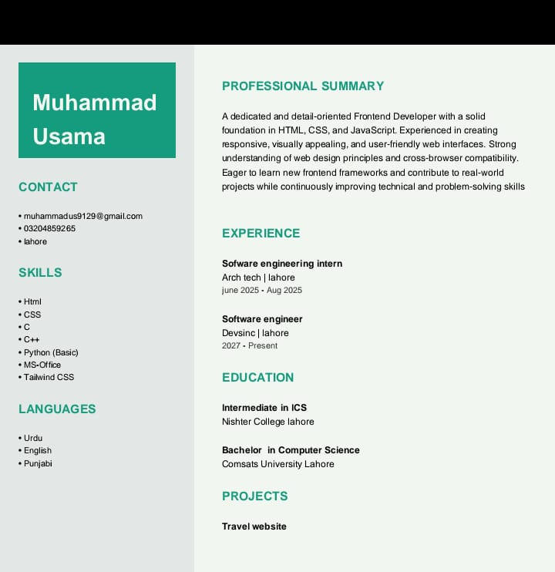

UML Diagram:
